**Warsaw University of Life Sciences (SGGW)**

**Dynamic and Financial Econometrics BDA**

**Turkey Stock Exchange (Borsa Istanbul)**

**Final Project**

**Cumali Bereket**

**s211060**

**Task 1**

**London Stock Exchange**

London Stock Exchange (LSE) is a [stock exchange](https://en.wikipedia.org/wiki/Stock_exchange) in the [City of London](https://en.wikipedia.org/wiki/City_of_London), [England](https://en.wikipedia.org/wiki/England), United Kingdom. As of November 2021, the total market value of all companies trading on LSE was 3.8 trillion USD. Its current premises are situated in [Paternoster Square](https://en.wikipedia.org/wiki/Paternoster_Square) close to [St Paul's Cathedral](https://en.wikipedia.org/wiki/St_Paul%27s_Cathedral) in the [City of London](https://en.wikipedia.org/wiki/City_of_London). It is part of [London Stock Exchange Group](https://en.wikipedia.org/wiki/London_Stock_Exchange_Group) (LSEG, that it also lists (LSE: [LSEG](https://www.londonstockexchange.com/stock/LSEG/))), which was created in 2007 when LSE acquired the [Italian stock exchange](https://en.wikipedia.org/wiki/Borsa_Italiana)

**Turkey Stock Exchange**

Turkey Market Capitalization accounted for 196.371 Billion USD in May 2021, compared with a percentage of 207.316 Billion USD in the previous month.

**Task 2**

**TURPS (Turkiye Petrolleri Rafinerileri)**

Description. Turkiye Petrol Rafinerileri A.S., together with its subsidiaries, engages in the refiningcrude oil, petroleum, and chemical products in Turkey and internationally. It is also involved in the purchase, sale, import, export, storage, and marketing of petroleum products, LPG, and natural gas.

**Koç Holding A.Ş**.

Koç holding is the largest industrial conglomerate in Turkey, and the only company in the country to be listed on the Fortune Global 500 as of 2016. The company, headquartered in Nakkaştepe, Istanbul, is controlled by the Koç family, one of Turkey's wealthiest families.

**Eregli Demir A.Ş**.

Eregli Demir Ve Celik Fabrikalari TAS is a Turkey-based company engaged in production of flat **steel,** long steel and other steel products. The company also provides engineering and project management services, as well as port services. As well, the company owns an iron ore mining arm.

**QNB Finansbank**

QNB Finansbank is **a** Turkish bank with headquarters in Levent, Istanbul. It was established by leading Turkish banker Hüsnü Özyeğin in 1987 and for a period was the Turkish bank with the largest network of foreign branches.

**Task 3**

**Bluechip whole period Autocorrelation**

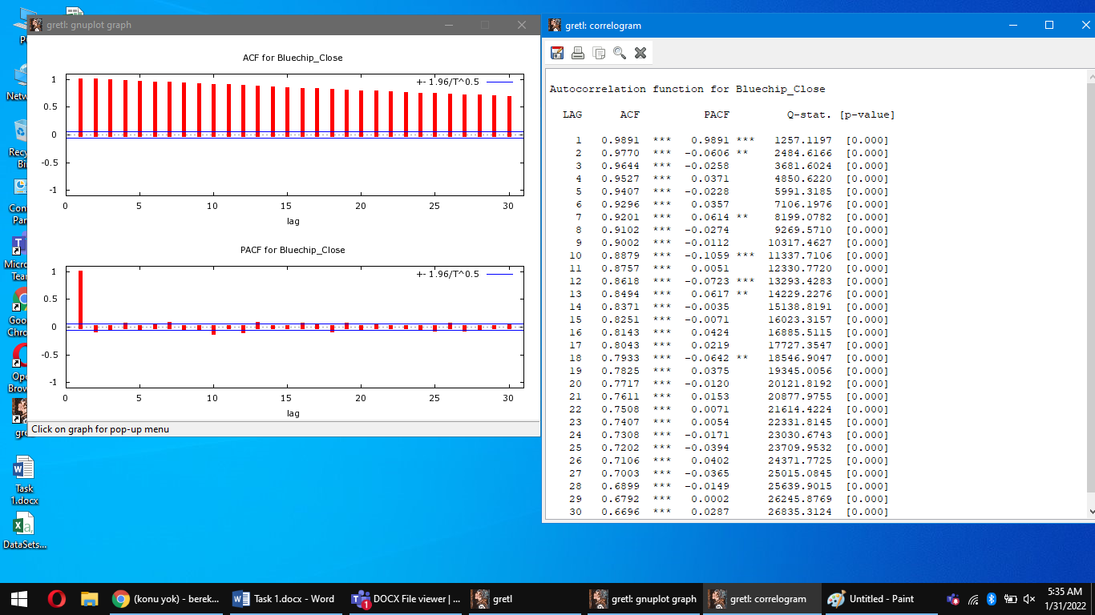

Applied test: Ljung-Box test   
H0: The data are independently distributed(White-noise).   
H1: The data are not independently distributed and they are correlated.

If we will check the ACF column, we can indicate that all Lags from 1 to 30 significant (p_value < than significance level 0.01), we can reject H0 and say that data is correlated. Also we can see it on the graph.   
   
The same thing we can see after checking the whole period of Energy, Material and Financial indices. In all cases we reject the H0 and observe autocorrelation.

**Bluechip Before Coronavirus (Before Lockdown)**

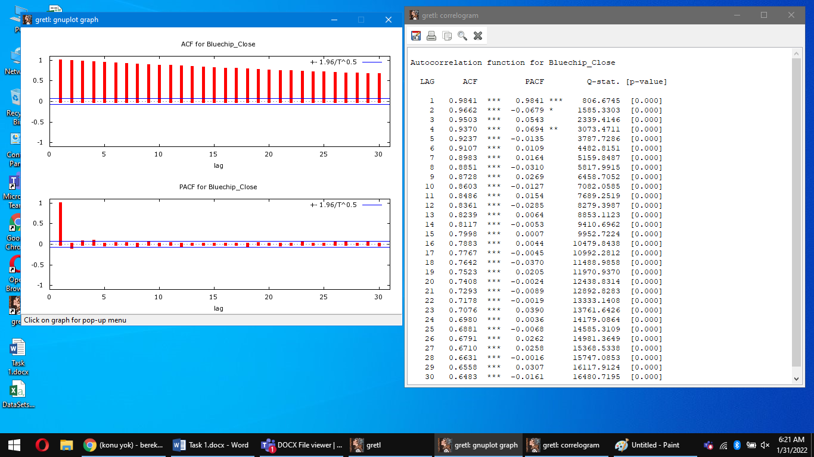

Applied test: Ljung-Box test   
H0: The data are independently distributed(White-noise).   
H1: The data are not independently distributed and they are correlated.    
If we will check the ACF column, we can indicate that all Lags from 1 to 30 significant (p_value < than significance level 0.01), we can reject H0 and say that data is correlated. Also we can see it on the graph. The same situation before coronavirus values of Energy, Construction and Finance.

**Bluechip After Coronavirus (After Lockdown)**

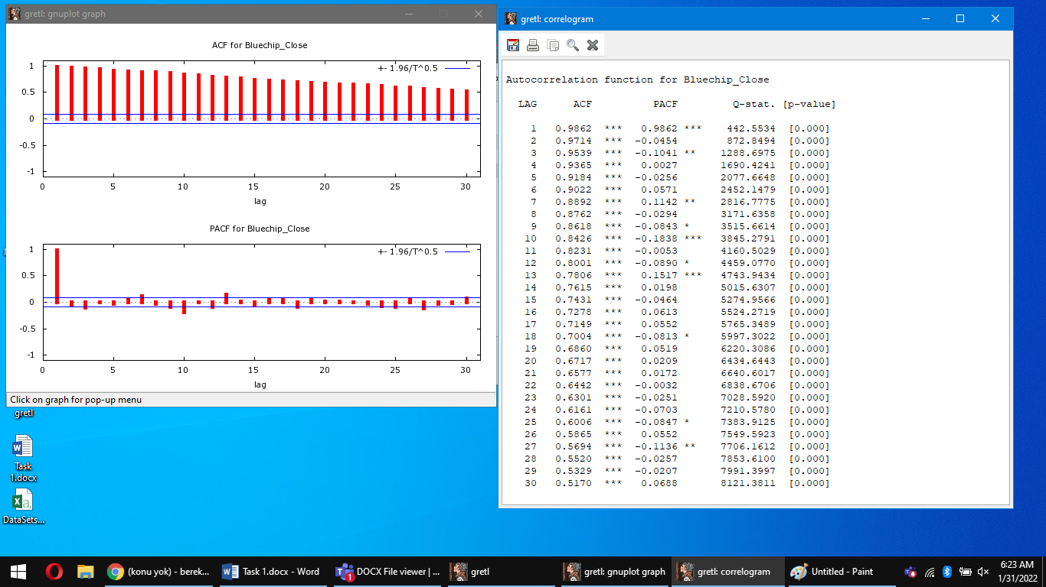

Applied test: Ljung-Box test   
H0: The data are independently distributed(White-noise).   
H1: The data are not independently distributed and they are correlated.    
If we will check the ACF column, we can indicate that all Lags from 1 to 30 significant (p_value < than significance level 0.01), we can reject H0 and say that data is correlated. Also we can see it on the graph.

The same situation after coronavirus we can see for Finance, Construction and Energy. For all cases we reject the H0 and observe autocorrelation.

**B) Substantive interpretation of the autocorrelation testing results**

If we will compare the results between two sub-periods (before and after coronavirus lockdown), we will observe that for example Blue-chip at before lockdown period and Blue-chip at after lockdown both got the autocorrelation and few partial-autocorrelation.

Now I want to check Construction. Let’s Analyze for Construction. As we can see the results are quite similar like Bluechip.

**Construction Before Lockdown**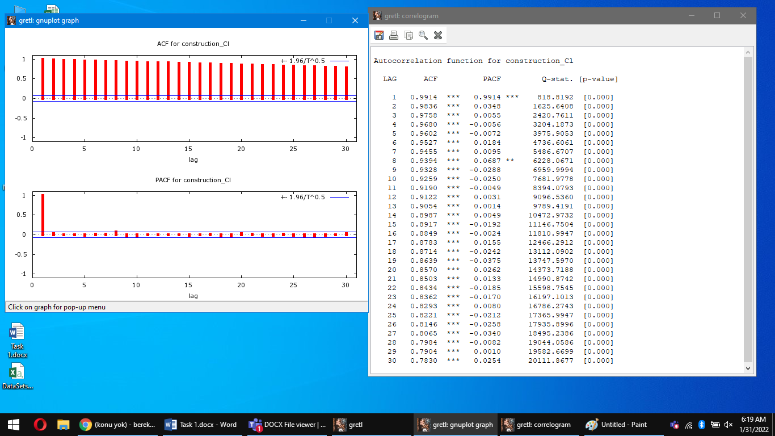

**Construction After Lockdown**

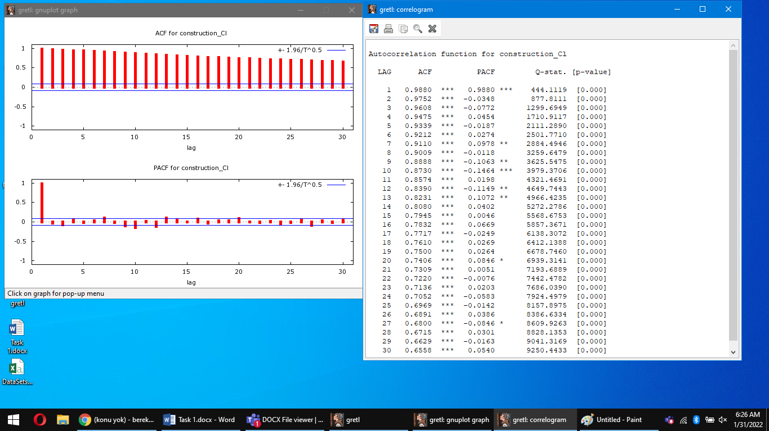

**Task 4**

A) Analysis of indices properties – ARCH effect

I want to start analyzing with Blue-chip index (whole period). First step is to check the time-series for stationarity by doing the ADF test. We need to prove that our time-series is stationary.

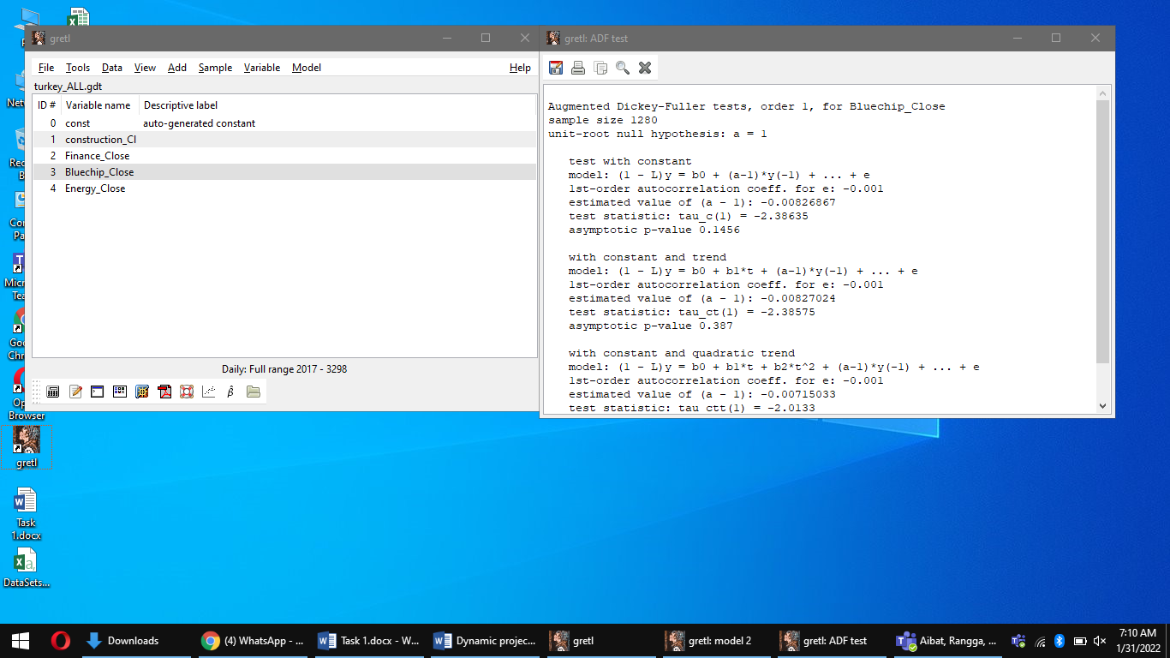

We can see our p value greater than 0.01 our value not stationary we should use first difference of variable step.

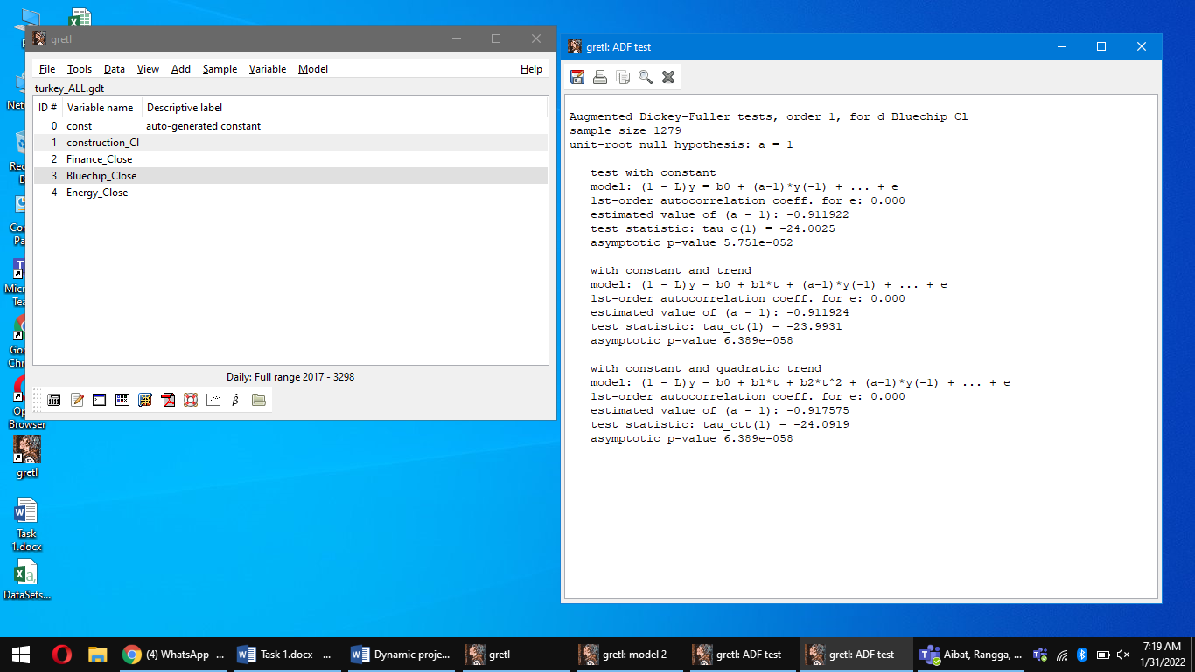

**Task 4**

Test for ARCH of order

We will start analyzing from Blue-chip index(whole period).  
First step is to check the time-series for stationarity by doing the ADF test. We need to prove that our time-series is stationary.

PARAMETER ESTIMATE STDERROR T STAT P-VALUE

alpha(0) 8.92393 3.00079 2.974 0.00303 ***

alpha(1) 0.833374 0.0349205 23.865 <0.00001 ***

alpha(2) -0.0246376 0.0454344 -0.542 0.58778

alpha(3) 0.0487366 0.0454077 1.073 0.28345

alpha(4) 0.0476677 0.0454246 1.049 0.29431

alpha(5) 0.0370252 0.0349103 1.061 0.28919

Null hypothesis: no ARCH effect is present

Test statistic: TR^2 = 701.995

with p-value = P(Chi-Square(5) > 701.995) = 1.81963e-149

We can see, p_value < 0.01, we can reject H0: There is no ARCH effect. And we can accept the H1:ARCH effect is present.  
  
We repeating all steps for other indices and got the same results. In all for indices ARCH effect is present.

I want to try with before lockdown. ADF test.

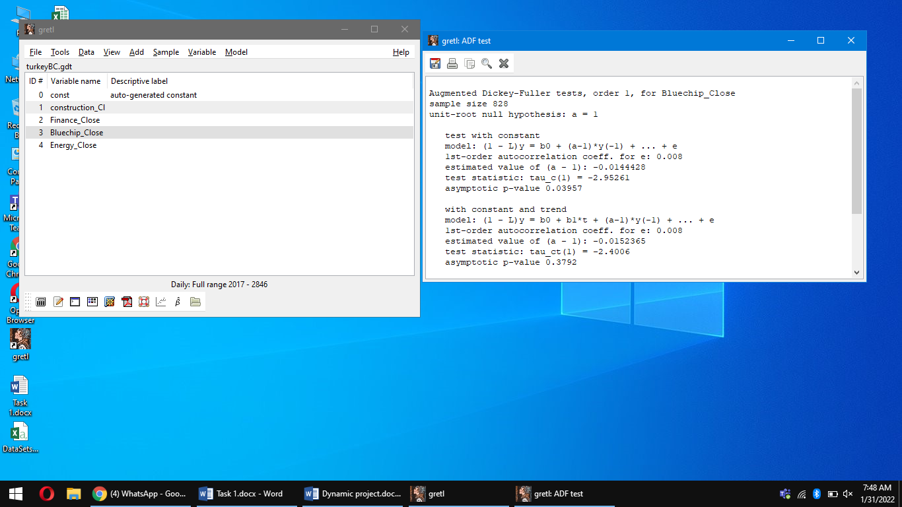

Our p value less than 1 it means our time series stationary

**Before lockdown Arch Effect**

Test for ARCH of order 5

PARAMETER ESTIMATE STDERROR T STAT P-VALUE

Alpha (0) 8.63123 3.26038 2.647 0.00840 ***

Alpha (1) 0.843873 0.0476710 17 .702 <0.00001 ***

Alpha (2) -0.0390432 0.0622768 -0.627 0.53103

Alpha (3) 0.0307923 0.0622984 0.494 0.62136

Alpha (4) 0.0764182 0.0623009 1.227 0.22063

Alpha (5) -0.0193219 0.0476731 -0.405 0.68545

Null hypothesis: no ARCH effect is present

Test statistic: TR^2 = 343.419

with p-value = P (Chi-Square (5) > 343.419) = 4.57005e-072

H0: There is no ARCH effect present  
H1: ARCH effect is present  
We reject H0, because p_value < 0.01. ARCH effect is present. Simillar results we have for other Indices in the period before the lockdown.

**After lockdown**

Test for ARCH of order 5

PARAMETER ESTIMATE STDERROR T STAT P-VALUE

alpha (0) 8.63123 3.26038 2.647 0.00840 ***

alpha (1) 0.843873 0.0476710 17.702 <0.00001 ***

alpha (2) -0.0390432 0.0622768 -0.627 0.53103

alpha (3) 0.0307923 0.0622984 0.494 0.62136

alpha (4) 0.0764182 0.0623009 1.227 0.22063

alpha (5) -0.0193219 0.0476731 -0.405 0.68545

Null hypothesis: no ARCH effect is present Test statistic: TR^2 = 343.419

with p-value = P (Chi-Square (5) > 343.419) = 4.57005e-072

B) Substantive interpretation of the ARCH effect testing results  
As we can see on the previous results, the ARCH effect is present in all analyzed time-series and it proved by providing ARCH test. Because the p-value in all analyzed Indices is lower than significance level, which means that we can reject H0. In comparison of whole period, we know that time-series are presenting ARCH effect. While we comparing sub-period indices, both of them got the ARCH effect. Their p_value suits to H1 and that is why we have ARCH effect.

**Part 2**

**Task 1**

Blue-chip(WP) by using KPSS test for checking the degree of integration in time-series.  
H0:Time-series is stationary and represents the 0 order  
H1:Time-series is nonstationary and represents the order 1  
T-statistics = 10.3694, 5% crit value = 0.462  
On use level of variable step we compare T-st with crit value, if it’s greater, then we cannot reject H0.  
Energy(WP): Test statistic = 7.5725 ,5% = 0.362, we cannot reject H0.

Materials(WP): Test statistic = 8.79626 ,5% = 0.362, we cannot reject H0.

Financial(WP): Test statistic = 3.72732 ,5% = 0.362, we cannot reject H0.

Blue-chip(BL): Test statistic = 2.21647, 5% = 0.362, we cannot reject H0.  
Energy(BL): Test statistic = 9.96254 ,5% = 0.362, we cannot reject H0.

Materials(BL): Test statistic = 2.82732 ,5% = 0.362, we cannot reject H0.

Financial(BL): Test statistic = 3.3971 ,5% = 0.362, we cannot reject H0.  
Blue-chip(AL): Test statistic = 4.93206, 5% = 0.362, we cannot reject H0.  
Energy(AL): Test statistic = 6.89488 ,5% = 0.362, we cannot reject H0.

Materials(AL): Test statistic = 5.54209 ,5% = 0.362, we cannot reject H0.

Financial(AL): Test statistic = 2.72286 ,5% = 0.362, we cannot reject H0.  
  
As we can see, all indices in whole period of time are not rejecting the null hypothesis and proves that they are stationary and don’t have integration orders in time-series. If we will compare the results of indices from before and after lockdown, they also cannot reject the H0, which means all time-series are stationary and don’t have integration orders.

**Task 2**

**Granger Casuality**

A) Granger causality analysis between analyzed indices LAGS: from 1 to 5  
As we already know, all indices are stationary.  
BC(WP)-En(WP):

Eq1: F(2, 1112) = 4.8831 [0.0066]  
Eq2: F(2, 1112) = 5.8426 [0.0033]

BC causes En because P-value < significance level  
BC(WP)-Ma(WP):

Eq1: F(2, 1112) = 2.6865 [0.0675]  
Eq2: F(2, 1112) = 5.2120 [0.0057]  
BC causes Ma because P_value < significance level

En(WP)-Fa (WP):

All lags of PriceConstruction F(2, 1122) = 3.7442 [0.0645]  
All lags of PriceEnergy F(2, 1122) = 7.5817 [0.0003]  
En causes Ma because P_value < significance level  
En(WP)-Fa (WP):

All lags of PriceFinancial F(1, 1212) = 0.0011374 [0.9733]  
All lags of PriceConstruction F(1, 1212) = 0.79158 [0.3733]  
There is no causality

Blue-chip(BL) – Energy(BL):   
All lags of PriceEnergy F(5, 759) = 2.1393 [0.3379]  
All lags of PriceBluechip F(5, 759) = 3.8803 [0.0138]  
BC(BL) causes En(BL) because P_value < significance level

Blue-chip(BL) – Ma(BL):   
All lags of PriceConstruction F(1, 880) = 1.3783 [0.2407]  
All lags of PriceBluechip F(1, 880) = 0.091088 [0.7628]  
There is no causality

Blue-chip(BL) – Fa(BL):   
All lags of PriceFinancial F(1, 880) = 0.35448 [0.5517]  
All lags of PriceBluechip F(1, 880) = 0.44892 [0.5032]  
There is no causality  
En(BL) – Ma(BL):   
All lags of PriceConstruction F(1, 880) = 1.0388 [0.3085]  
All lags of PriceEnergy F(1, 880) = 0.18506 [0.6673]  
There is no causality

En(BL) – Fa(BL):   
All lags of PriceFinancial F(2,667)= 7.0115 [0.0011]  
All lags of PriceEnergy F(2, 667) = 2.2164 [0.1099]  
Fa(BL) causes En(BL) because P_value < sig.value

Ma(BL) – Fa(BL):   
All lags of PriceFinancial F(1, 880) = 0.19423 [0.6598]  
All lags of PriceConstruction F(1, 880) = 1.6022 [0.2066]  
There is no causality  
BC(AL) – En(AL):   
All lags of PriceEnergy F(2, 667) = 0.64135 [0.5272]  
All lags of PriceBluechip F(2, 667) = 2.9166 [0.0553]  
There is no causality  
BC(AL) – Ma(AL):   
All lags of PriceConstruction F(1, 439) = 1.4205 [0.2344]  
All lags of PriceBluechip F(1, 439) = 3.4473 [0.0644]  
There is no causality  
BC(AL) – Fa(AL):   
All lags of PriceFinancial F(1, 539) = 0.28113 [0.5963]  
All lags of PriceBluechip F(1, 539) = 0.00013666 [0.9908]  
There is no causality  
En(AL) – Ma(AL):   
All lags of PriceConstruction F(2, 437) = 5.9372 [0.0028]  
All lags of PriceEnergy F(2, 438) = 7.1231 [0.0008]  
En(AL) causes Ma(AL) because P_value < sig.value

En(AL) – Fa(AL):   
All lags of PriceFinancial F(2, 436) = 1.6598 [0.1914]  
All lags of PriceEnergy F(2, 436) = 2.2372 [0.1080]  
There is no causality  
Ma(AL) – Fa(AL):   
All lags of PriceFinancial F(2, 436) = 0.22542 [0.7983]  
All lags of PriceConstruction F(2, 436) = 0.76627 [0.4654]  
There is no causality  
  
**Part 3  
Cointegration**   
First step, we are checking for stationarity of time-series by using ADF test. Johansen test  
Whole period indices first.  
Blue-chip(WP):

By using the first difference of variable in test without constant p_value = 1.62e-033 < significance level, we reject H0 and time-series is stationary.   
Energy(WP):

By using the first difference of variable in test without constant p_value = 1.06e-017 < significance level, we reject H0 and time-series is stationary.

Construcrion(WP):

By using the first difference of variable in test without constant p_value = 1.29e-025 < significance level, we reject H0 and time-series is stationary.

Financial(WP):

By using the first difference of variable in test with constant p_value = 0.0027 < significance level, we reject H0 and time-series is stationary.  
Blue-chip(WP) – Energy(WP)-Costruction(WP)-Financial(WP):

We making the VAR lag selection and find the lag 2 as the significant one in AIC.( 38.376556*).

Then we conducting the Johansen Test with indices with lag 2.   
At rank 0 we got the p_value = 0.0025< significance level and we can reject H0: There is no cointegrating vectors and accept H1: There are 1 or more cointegrating vectors in time-series.  
We finish the Johansen Test because at the rank 1 the p_value of Eigen Value test is greater then significance level.

Blue-chip(WP) – Energy(WP):   
We making the VAR lag selection and find the lag 2 as the significant one in AIC.( 19.366763*).  
Then we conducting the Johansen Test with indices with lag 2.

At rank 0 we got the p_value = 0.2555< significance level and we cannot reject H0. Here are no cointegrating vectors.  
Blue-chip(WP)-Construction(WP):   
We making the VAR lag selection and find the lag 2 as the significant one in AIC.( 19.366764*).  
Then we conducting the Johansen Test with indices with lag 2.  
At rank 0 we got the p_value = 0.1341< significance level and we cannot reject H0. Here are no cointegrating vectors.

Blue-chip(WP)-Financial(WP):   
We making the VAR lag selection and find the lag 9 as the significant one in AIC.( 20.840486*).  
Then we conducting the Johansen Test with indices with lag 9.  
At rank 0 we got the p_value = 0.1552< significance level and we cannot reject H0. Here are no cointegrating vectors.

Energy(WP)-Construction(WP):   
We making the VAR lag selection and find the lag 10 as the significant one in AIC.( 18.304398*).

Then we conducting the Johansen Test with indices with lag 10.   
At rank 0 we got the p_value = 0.5153< significance level and we cannot reject H0. Here are no cointegrating vectors.  
Energy(WP)-Financial(WP):

We making the VAR lag selection and find the lag 2 as the significant one in AIC.( 19.963795*).

Then we conducting the Johansen Test with indices with lag 2.   
At rank 0 we got the p_value = 0.0492< significance level and we can reject H0: There is no cointegrating vectors and accept H1: There are 1 or more cointegrating vectors in time-series.  
We finish the Johansen Test because at the rank 1 the p_value of Eigen Value test is greater then significance level.

Construction(WP)-Financial(WP):

We making the VAR lag selection and find the lag 1 as the significant one in AIC.( 20.996032*).

Then we conducting the Johansen Test with indices with lag 1.   
At rank 0 we got the p_value = 0.1168< significance level and we cannot reject H0. Here are no cointegrating vectors.   
Blue-chip(BL):

By using the use level of variable in test without constant p_value = 0.0046< significance level, we reject H0 and time-series is stationary.   
Energy(BL):

By using the use level of variable in test with constant and trend p_value = 0.0023< significance level, we reject H0 and time-series is stationary.   
Construction(BL):

By using the use level of variable in test with constant p_value = 0.0293< significance level, we reject H0 and time-series is stationary.

Financial(BL):

By using the use level of variable in test with constant p_value = 0.0224< significance level, we reject H0 and time-series is stationary.

Blue-chip(BL) – Energy(BL)-Construction(BL)-Financial(BL):   
We making the VAR lag selection and find the lag 2 as the significant one in AIC.( 36.059017*)  
Then we conducting the Johansen Test with all 4 indices with lag 2.

At rank 0 we got the p_value = 0.9775< significance level and we cannot reject H0. Here are no cointegrating vectors.  
Blue-chip(BL) – Energy(BL):   
We making the VAR lag selection and find the lag 5 as the significant one in AIC.( 18.406494*).  
Then we conducting the Johansen Test with indices with lag 5.

At rank 0 we got the p_value = 0.8500< significance level and we cannot reject H0. Here are no cointegrating vectors.  
Blue-chip(BL)=Construction(BL):   
We making the VAR lag selection and find the lag 1 as the significant one in AIC.( 19.010916*).  
Then we conducting the Johansen Test with indices with lag 1.  
At rank 0 we got the p_value = 0.6006< significance level and we cannot reject H0. Here are no cointegrating vectors.

Blue-chip(BL)-Financial(BL):   
We making the VAR lag selection and find the lag 1 as the significant one in AIC.( 19.988263*).  
Then we conducting the Johansen Test with indices with lag 1.  
At rank 0 we got the p_value = 0.2346< significance level and we cannot reject H0. Here are no cointegrating vectors.

Energy(BL)-Construction(BL):   
We making the VAR lag selection and find the lag 1 as the significant one in AIC.( 17.150383*).

Then we conducting the Johansen Test with indices with lag 1.   
At rank 0 we got the p_value = 0.8335< significance level and we cannot reject H0. Here are no cointegrating vectors.  
Energy(BL)-Financial(BL):

We making the VAR lag selection and find the lag 2 as the significant one in AIC.( 19.401686*).

Then we conducting the Johansen Test with indices with lag 2.   
At rank 0 we got the p_value = 0.5901< significance level and we cannot reject H0. Here are no cointegrating vectors.  
Construction(BL)-Financial(BL):

We making the VAR lag selection and find the lag 1 as the significant one in AIC.( 20.255105*).

Then we conducting the Johansen Test with indices with lag 1.   
At rank 0 we got the p_value = 0.2485< significance level and we cannot reject H0. Here are no cointegrating vectors.   
Blue-chip(AL):

By using the use level of variable in test without constant p_value = 2.11e-042 ***< significance level, we reject H0 and time-series is stationary.   
Energy(AL):

By using the use level of variable in test with constant and trend p_value = 0.0086< significance level, we reject H0 and time-series is stationary.

Construction(AL):

By using the use level of variable in test with constant and trend p_value = 0.0394**< significance level, we reject H0 and time-series is stationary.

Financial(AL):

By using the use level of variable in test with constant p_value = 0.0412< significance level, we reject H0 and time-series is stationary.

Blue-chip(AL) – Energy(AL)-Construction(AL)-Financial(AL):   
We making the VAR lag selection and find the lag 2 as the significant one in AIC.( 40.319293*)  
Then we conducting the Johansen Test with all 4 indices with lag 2.

At rank 0 we got the p_value = 0.0002< significance level and we can reject H0: There is no cointegrating vectors and accept H1: There are 1 or more cointegrating vectors in time-series.  
We finish the Johansen Test because at the rank 1 the p_value of Eigen Value test is greater then significance level.  
Blue-chip(AL) – Energy(AL):   
We making the VAR lag selection and find the lag 2 as the significant one in AIC.( 20.219108*).  
Then we conducting the Johansen Test with indices with lag 2.

At rank 0 we got the p_value = 0.2069< significance level and we cannot reject H0. Here are no cointegrating vectors.  
Blue-chip(AL)-Construction(AL):   
We making the VAR lag selection and find the lag 1 as the significant one in AIC.( 21.027315*).  
Then we conducting the Johansen Test with indices with lag 1.  
At rank 0 we got the p_value = 0.6006< significance level and we cannot reject H0. Here are no cointegrating vectors.

Blue-chip(AL)-Financial(AL):   
We making the VAR lag selection and find the lag 1 as the significant one in AIC.( 21.616206*).  
Then we conducting the Johansen Test with indices with lag 1.  
At rank 0 we got the p_value = 0.5583< significance level and we cannot reject H0. Here are no cointegrating vectors.

Energy(AL)-Construction(AL):   
We making the VAR lag selection and find the lag 2 as the significant one in AIC.( 19.365693*).

Then we conducting the Johansen Test with indices with lag 2.   
At rank 0 we got the p_value = 0.0333< significance level and we can reject H0: There is no cointegrating vectors and accept H1: There are 1 or more cointegrating vectors in time-series.

At rank 1 we got the p_value = 0.0157< significance level and we can reject H0: There is 1 cointegrating vector and accept H1: There are 2 or more cointegrating vectors in time-series.  
Energy(AL)-Financial(AL):

We making the VAR lag selection and find the lag 2 as the significant one in AIC.( 20.577078*).

Then we conducting the Johansen Test with indices with lag 2.   
At rank 0 we got the p_value = 0.3758< significance level and we cannot reject H0. Here are no cointegrating vectors. Construction(BL)-Financial(BL):

We making the VAR lag selection and find the lag 1 as the significant one in AIC.( 21.724318*).

Then we conducting the Johansen Test with indices with lag 1.   
At rank 0 we got the p_value = 0.6123< significance level and we cannot reject H0. Here are no cointegrating vectors.

**Task 5**

**Randomness**

**For whole period**

Analysis of indices properties randomness of changes in the analyzed time series/

We use run test

H0: the analyzed sequence is random sequence

H1: the analyzed sequence not random

If Z< 1.96 We reject H0

Runs test (first difference)

Number of runs (R) in the variable 'construction_Cl' = 604

Under the null hypothesis of randomness, R follows N(641.5, 17.8885)

z-score = 2.09631, with two-tailed p-value 0.0360544

Runs test (first difference)

Number of runs (R) in the variable 'Finance_Close' = 567

Under the null hypothesis of randomness, R follows N(641.5, 17.8885)

z-score = 4.16468, with two-tailed p-value 3.11794e-005

Runs test (first difference)

Number of runs (R) in the variable 'Bluechip_Close' = 602

Under the null hypothesis of randomness, R follows N(641.5, 17.8885)

z-score = 2.20812, with two-tailed p-value 0.0272361

uns test (first difference)

Number of runs (R) in the variable 'Energy_Close' = 608

Under the null hypothesis of randomness, R follows N(641.5, 17.8885)

z-score = 1.87271, with two-tailed p-value 0.0611089

For Construction Close , Finance Close, BlueChip Close Z > 1.96 We reject H0 the analyzed sequence is random but for Energy Close Z<1.96 we can’t reject H0 the energy close sequence is not random.